Document Type

Title

Abstract
This is the abstract.
DOCUMENT PREPARED BY: | DOCUMENT CHECKED BY: | DOCUMENT APPROVED BY:
Names | Names | Names

HISTORY OF CHANGES
REV. NO. | DATE | PAGES | DESCRIPTIONS OF THE CHANGES
0.1 | 2022-05-22 | ? | First draft
0.2 | 2022-yy-xx | ?
0.3 | 2022-yy-xx | ?
1.0 | 2022-yy-xx | ? | First approved version.

TABLE OF CONTENTS

Title 1
Abstract 1
Executive Summary 5
Glossary (not necessarily needed) 5
1. Introduction 6
2. Section 2 6
3. Section 3 6
4. Section 4 6
4.1 SubSection 4.1 6
4.2 SubSection 4.2 6
4.2.1 SubSubSection 4.2.1 6

Executive Summary
You might want to have it

AAAA | BBBB | CCC
xx | 0 | 3.
xx | 0 | 7.0
xx | 0 | 0.0
xx | 0 | 1.0
x | 0 | 3.0
x | 0 | 5
x | 0
Total | xx | yy
Table 1: Example of a table.

.

Glossary (not necessarily needed)

Aaa | xxx
Bbb | yyy
Ccc | zzz
ddd | www.

Introduction
Introduction.

Section 2
This is Section 2

Section 3
This is Section 3 and it contains Fig. 1.
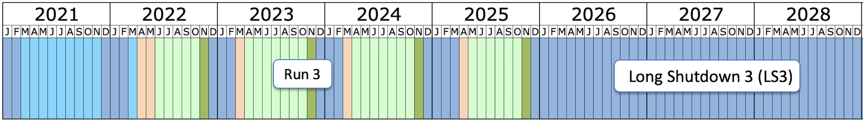
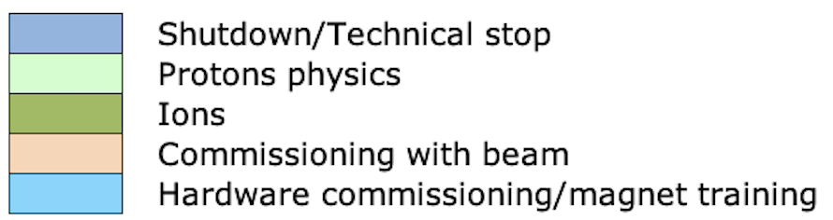
Figure 1: LHC schedule between 2021 and 2028 (Jan. 2022).

Section 4
This is Section 4

SubSection 4.1
This is Subsection 4.1

SubSection 4.2
This is Subsection 4.1

SubSubSection 4.2.1
This is SubSubSection 4.2.1

